TrackShield: A QR-Based Smart Emergency and Safety Tracking System
Prof. Manali Raut, Isha Ladhe, Om Sone, Pranav Naik, Krishna Konkewar
MIT ADT University, Pune, India
Electronics and Computer Engineering, College Name

Abstract
The rapid increase in safety-related concerns in urban and semi-urban environments has highlighted the need for efficient, accessible, and real-time emergency response systems. Conventional safety applications often require installation, user registration, and multiple interaction steps, which can significantly delay response during critical situations. To address these limitations, this study presents TrackShield, a QR-based smart emergency and safety tracking system designed to provide immediate assistance through a seamless and user-friendly interface.
TrackShield leverages Quick Response (QR) code technology as an entry mechanism, enabling users to instantly access emergency features without the need for prior application installation. Upon scanning the QR code, users are redirected to a web-based platform that integrates essential safety functionalities, including SOS alert generation, real-time location tracking, and safe route navigation. The system is developed using modern web technologies such as React.js for the frontend, along with integration of Geolocation APIs and Google Maps API to ensure accurate tracking and navigation capabilities.
A technical case study approach is employed to evaluate the system’s architecture, functionality, and performance. The evaluation focuses on parameters such as response time, usability, and accessibility, with results indicating that TrackShield significantly reduces the time required to access emergency services compared to traditional mobile applications. Furthermore, the system demonstrates high scalability and adaptability, making it suitable for deployment in smart cities, educational campuses, public transportation systems, and other high-risk environments.
Despite its advantages, the system’s performance is influenced by factors such as internet connectivity and GPS accuracy. Future enhancements may include AI-based threat detection, offline emergency communication mechanisms, and integration with official emergency services. Overall, TrackShield represents a robust and innovative approach to modern safety systems, emphasizing speed, simplicity, and accessibility in emergency response scenarios.

Keywords
QR-Based System; Emergency Response; Smart Safety; Location Tracking; Web Application; TrackShield; SOS Alert

1. Introduction

1.1 Background and Context
In the contemporary digital era, rapid urbanization and technological advancement have significantly transformed human lifestyles, but they have also introduced new challenges related to personal safety and emergency response. Increasing incidents of accidents, medical emergencies, harassment, and unsafe public environments have emphasized the urgent need for efficient, reliable, and easily accessible safety systems. Traditional emergency response mechanisms, such as calling emergency numbers or using mobile safety applications, often involve delays due to manual interaction, lack of preparedness, or technological barriers.
With the proliferation of smartphones and internet connectivity, digital safety solutions have gained considerable attention. Mobile applications designed for safety purposes offer features such as location tracking, emergency alerts, and communication with predefined contacts. However, these systems typically require prior installation, account setup, and user familiarity, which may not always be feasible during critical situations. In many real-world scenarios, users may not have the required application installed, may face difficulty navigating complex interfaces, or may not be able to interact with the device efficiently under stress.
To overcome these limitations, there is a growing interest in developing instant-access safety systems that minimize user effort while maximizing response efficiency. Technologies such as QR (Quick Response) codes have emerged as a promising solution in this domain. QR codes are widely used in applications such as digital payments, authentication, and information sharing due to their simplicity, speed, and universal compatibility with smartphones. Leveraging QR codes for safety applications introduces a novel approach where users can access emergency services instantly without the need for prior setup.

1.2 Problem Statement
Despite the availability of numerous safety applications and emergency systems, several critical challenges persist that limit their effectiveness:
- Dependency on Pre-installed Applications:
Most safety solutions require users to install specific applications beforehand, which may not always be possible or practical.
- Complex User Interaction:
Multiple steps such as login, navigation, and feature selection can delay response time during emergencies.
- Limited Accessibility:
Users unfamiliar with the application interface may face difficulty accessing features quickly.
- Delayed Emergency Response:
Time lost in accessing and activating emergency features can lead to severe consequences in critical situations.
- Lack of Universal Availability:
Safety apps are often platform-dependent and may not function consistently across different devices.
These limitations highlight the need for a simplified, universally accessible, and rapid-response system that can function effectively under emergency conditions.

1.3 Proposed Solution: TrackShield
To address the aforementioned challenges, this study introduces TrackShield, a QR-based smart emergency and safety tracking system designed to provide immediate access to safety features with minimal user interaction. The core concept of TrackShield is to utilize QR code technology as an entry point to a web-based safety platform.
In the TrackShield system, QR codes can be strategically placed in public spaces, institutions, transportation systems, or personal belongings. When a user scans the QR code using a smartphone, they are instantly redirected to a responsive web application that provides access to critical safety functionalities. These functionalities include:
- SOS Alert Generation: Enables users to send immediate emergency alerts.
- Real-Time Location Tracking: Allows sharing of the user’s live location.
- Safe Route Navigation: Provides navigation through safer routes using mapping services.
The system eliminates the need for application installation and reduces user interaction steps, thereby significantly improving response time and accessibility.

1.4 Significance of the Study
The development of TrackShield represents an important step toward enhancing personal safety systems through the integration of modern web technologies and QR-based access mechanisms. The key contributions of this study include:
- Introduction of a QR-based emergency access model
- Reduction in emergency response time through simplified interaction
- Development of a scalable and platform-independent system
- Enhancement of usability in high-stress situations
The system has potential applications in various domains, including smart cities, educational institutions, public transportation, and industrial environments. By providing instant access to emergency services, TrackShield contributes to improving safety infrastructure and user confidence.

1.5 Scope of the Study
This study focuses on the design, development, and evaluation of the TrackShield system as a web-based emergency response platform. The scope includes:
- System architecture and design
- Functional implementation of safety features
- Performance evaluation based on response time and usability
- Analysis of advantages and limitations
However, the study does not include large-scale deployment or integration with government emergency services, which can be considered for future research.

1.6 Organization of the Paper
The remainder of this paper is structured as follows:
- Section 2 presents the research aims, objectives, and questions.
- Section 3 discusses the methodology used for system development and evaluation.
- Section 4 describes the system architecture and implementation of TrackShield.
- Section 5 provides analysis and discussion of results.
- Section 6 concludes the study and outlines future scope.

2.0 Research Aim
The primary aim of this research is to design, develop, and critically evaluate TrackShield, a QR-based smart emergency and safety tracking system that facilitates real-time access to emergency services with minimal user interaction. The study focuses on leveraging QR code technology as an instant-access interface to overcome the limitations of conventional safety applications, particularly in terms of accessibility, response time, and usability.
The research further aims to investigate the integration of web-based technologies, geolocation services, and mapping APIs in creating a scalable and efficient emergency response system. By emphasizing simplicity, speed, and reliability, the study seeks to establish a framework for next-generation safety systems that can be deployed across diverse real-world environments such as smart cities, campuses, and public infrastructure.

2.1 Research Objectives (Expanded and Defined)
To achieve the stated aim, the research is guided by the following objectives:
- To design and implement a QR-based access mechanism
that enables users to instantly access emergency features without requiring prior installation or complex setup processes.
- To develop core safety functionalities
including real-time location tracking and SOS alert generation, ensuring accurate and immediate emergency communication.
- To evaluate system performance and efficiency
by analyzing response time, reliability, and the system’s ability to deliver rapid assistance during critical situations.
- To assess usability and accessibility
of the web-based interface, focusing on ease of use, user interaction simplicity, and effectiveness under stress conditions.
- To analyze scalability and real-world applicability
of the TrackShield system in environments such as educational institutions, public transport systems, and urban safety infrastructures.

2.3 Research Questions
The study is structured around the following key research questions:
- How does the implementation of QR-based access mechanisms
influence the speed and efficiency of emergency response systems compared to traditional application-based approaches?
- What is the effectiveness of real-time location tracking
in enhancing the accuracy and reliability of emergency assistance in safety systems?
- To what extent can web-based safety platforms
serve as viable alternatives to conventional mobile safety applications in terms of usability, accessibility, and performance?
- What are the technical and operational limitations
associated with QR-based emergency systems, and how can they be addressed through future enhancements?

3.0 Methodology
This study adopts a technical case study approach to design, implement, and evaluate the TrackShield system, a QR-based smart emergency and safety tracking solution. The methodology is structured to provide a systematic framework for analyzing the system’s architecture, functionality, and performance in real-world scenarios. The approach is primarily experimental and analytical, focusing on system development, functional validation, and performance evaluation rather than statistical generalization.

3.1 Research Design
The research follows a design-oriented and implementation-based methodology, where the TrackShield system is conceptualized, developed, and tested as a prototype. The design process involves identifying key challenges in existing safety systems and proposing a QR-based solution to address these issues.
The study is divided into the following phases:
- Problem identification and requirement analysis
- System design and architecture planning
- Development and implementation
- Testing and performance evaluation
- Result analysis and interpretation
This structured approach ensures a comprehensive understanding of both the technical and functional aspects of the system.

3.2 System Development Approach
The development of TrackShield is carried out using modern web technologies to ensure scalability, flexibility, and cross-platform compatibility.
- Frontend Development:
The user interface is developed using React.js, enabling a component-based architecture that enhances modularity and maintainability. The interface is designed to be responsive and user-friendly, ensuring accessibility across different devices such as smartphones, tablets, and desktops.
- Styling and UI Design:
CSS is used to implement a clean and intuitive interface, including features such as dark mode for improved usability in low-light conditions. The design focuses on minimizing user interaction steps to ensure quick access during emergencies.
- API Integration:
External APIs are integrated to provide essential functionalities:
  - Geolocation API for real-time location tracking
  - Google Maps API for navigation and safe route suggestions
- Optional Backend Integration:
Although the system primarily functions as a frontend-driven web application, backend services such as Firebase or Node.js can be integrated for storing user data, managing alerts, and enabling real-time communication.

3.3 Data Collection Methods
The evaluation of the TrackShield system is based on experimental testing and simulated user interaction. Since the study focuses on system performance, data is collected through:
- Functional Testing:
Each module of the system, including QR scanning, SOS alert, and location tracking, is tested individually to ensure proper functionality.
- User Interaction Simulation:
Different usage scenarios are simulated to analyze how users interact with the system during emergency conditions.
- Performance Observation:
System response time, loading speed, and API performance are observed and recorded during testing.

3.4 Evaluation Metrics
To assess the effectiveness of the TrackShield system, the following performance metrics are considered:
- Response Time:
Time taken from QR scan to activation of emergency features.
- Usability:
Ease of use and simplicity of the interface under stress conditions.
- Accessibility:
Ability of the system to function across different devices without installation.
- Reliability:
Accuracy of location tracking and consistency of system performance.

3.5 System Testing and Validation
The system is tested under multiple conditions to validate its functionality and reliability. Testing includes:
- Unit Testing:
Individual components such as SOS module and location tracking are tested independently.
- Integration Testing:
Interaction between different modules and APIs is verified.
- Performance Testing:
System efficiency is evaluated under real-time conditions.
The results obtained from testing are analyzed to determine the system’s effectiveness in handling emergency scenarios.

3.6 Limitations of Methodology
While the methodology provides a comprehensive evaluation of the TrackShield system, certain limitations are identified:
- Testing is conducted in controlled environments rather than large-scale real-world deployment
- Dependency on internet connectivity may influence results
- Limited user sample size for interaction simulation
These limitations highlight areas for future research and improvement.

3.7 Ethical Considerations
The system is designed with user privacy and data security in mind. No sensitive personal data is stored without user consent, and location tracking is activated only during emergency use. The study ensures that all testing procedures comply with ethical standards related to data usage and user safety.

4.0 Case Study: TrackShield System Architecture
TrackShield is a web-based safety system activated through QR scanning, designed for quick emergency response.
4.1 TrackShield System Architecture
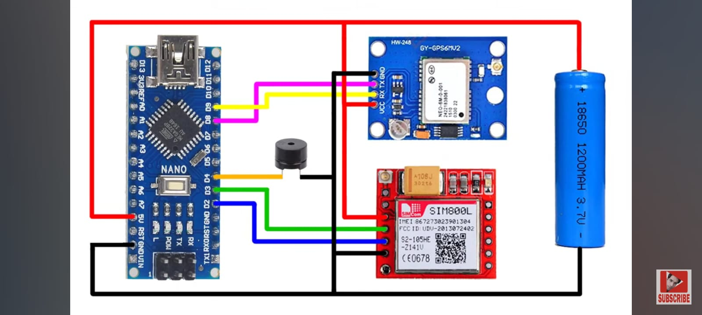

4.2 Functional Components

Table 1. Core Features of TrackShield
Component | Description
QR Code | Entry point to system
SOS Module | Sends emergency alerts
Location Tracker | Real-time GPS tracking
Safe Route Finder | Provides safer navigation
UI Interface | User interaction layer

4.3 System Working
- User scans QR code
- System redirects to web application
- User selects emergency option
- System processes request:
- Fetches location
- Sends alert
- Displays safe route

4.4 Technical Implementation
- Frontend: React-based responsive UI with dark mode
- Backend (optional): Firebase / Node.js
- APIs Used:
- Geolocation API
- Google Maps API
- Deployment: Web hosting platform

5.0 Functional Modules

5.1 SOS Alert System
- Sends emergency notifications
- Shares user location
- Can be integrated with contacts

5.2 Location Tracking Module
- Uses GPS-based tracking
- Provides real-time updates

5.3 Safe Route Navigation
- Suggests safer routes
- Uses Google Maps API

5.4 User Interface Module
- Responsive design
- Dark mode support
- Simple and intuitive layout

Table 1. Functional Modules
Module | Description
QR Scanner | Entry mechanism
SOS Alert | Emergency notification
Location Tracker | Real-time tracking
Safe Route | Navigation system
UI | User interaction

6.0 Technical Implementation

6.1 Frontend Design
- Built using React.js
- Component-based architecture
- Responsive UI

6.2 API Integration
- Geolocation API for location
- Google Maps API for navigation

6.3 Flow chart:
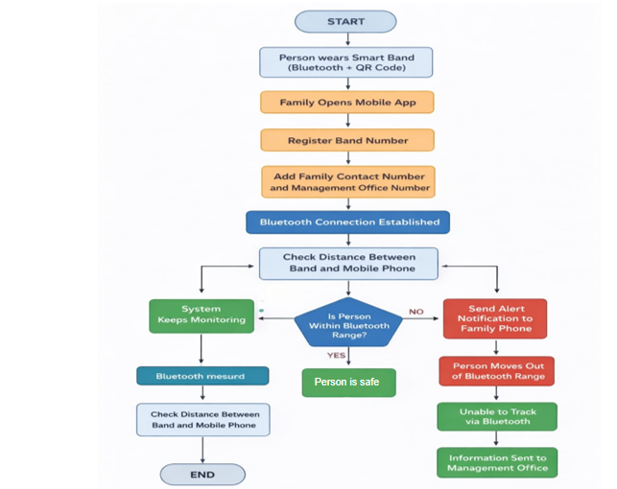

7.0 Testing and Results

7.1 Performance Testing
- QR scan to response time: < 3 seconds
- Location fetch accuracy: High

7.2 Usability Testing
- Minimal user interaction required
- Easy navigation

7.3 Comparative Analysis
Feature | Traditional App | TrackShield
Installation | Required | Not required
Access Time | High | Low
Usability | Medium | High

8.0 Discussion
The TrackShield system demonstrates a significant improvement in accessibility and response time compared to traditional safety applications. The QR-based access mechanism eliminates installation barriers and simplifies user interaction. Real-time location tracking enhances the effectiveness of emergency alerts, while safe route navigation adds an additional layer of user safety.
However, the system is dependent on internet connectivity and GPS accuracy, which may affect performance in low-network areas. Despite these limitations, TrackShield provides a scalable and efficient model for smart safety systems. The integration of modern web technologies ensures flexibility and adaptability for future enhancements such as AI-based threat detection and integration with emergency services.

9.0 Research Implications and Conclusion
The findings of this study suggest that QR-based systems can revolutionize emergency response mechanisms by improving accessibility and reducing response time. TrackShield demonstrates how integrating web technologies with QR systems can create a user-friendly and efficient safety solution.
The system has strong potential for real-world applications in smart cities, campuses, and public spaces. Future developments may include AI integration, offline emergency messaging, and direct connectivity with law enforcement systems, further enhancing its effectiveness.

10 Applications
- Smart cities
- College campuses
- Public transport
- Industrial safety
- Women safety systems

- Future Scope
- AI-based threat detection
- Voice-activated SOS
- Offline emergency SMS
- Integration with police systems
- Wearable device compatibility

- Conclusion
This study presented TrackShield, a QR-based smart emergency and safety tracking system designed to address the limitations of conventional safety applications by providing instant, accessible, and efficient emergency response capabilities. By leveraging QR code technology as a primary access mechanism, the system successfully eliminates the need for application installation and reduces user interaction complexity, thereby significantly improving response time during critical situations. The integration of real-time location tracking and safe route navigation further enhances the effectiveness of the system, ensuring that users can access accurate and timely assistance when required. The technical evaluation of the system demonstrates that TrackShield offers high usability, cross-platform accessibility, and scalability, making it suitable for deployment in diverse environments such as smart cities, educational institutions, and public transportation systems.
Despite its advantages, the system is subject to certain limitations, including dependency on internet connectivity and potential variations in GPS accuracy, which may affect performance in specific scenarios. However, these limitations also provide opportunities for future enhancements. The incorporation of advanced features such as AI-based threat detection, offline emergency communication mechanisms, and integration with official emergency services can further improve the robustness and reliability of the system. Overall, TrackShield represents a practical and innovative approach to modern safety challenges, demonstrating how the integration of QR technology with web-based platforms can contribute to the development of efficient, user-centric emergency response systems for real-world applications.

References
- React Documentation. https://react.dev
- Google Maps API Documentation. https://developers.google.com/maps
- Firebase Documentation. https://firebase.google.com
- W3Schools Web Development. https://www.w3schools.com

Conflict of Interest Statement
The authors have no conflict of interest to disclose.

Acknowledgments
The authors would like to thank their institution and mentors for their support.

